

Project Proposal

AI Financial Wellness Coach

Practice Module for Certificate in Architecting AI Systems

Team 9
Lee Jet Xuen (Sky)
Lim Keng Yen Bernard
Mar Wen Hee
Tan Sean Leng
Lai Xin Kai

CONTENTS
1. Overview 3
1.1 Project Context 3
1.2 Business Needs 3
1.3 General Architecture 4
1.4 Project Scope 4
2. Project Plan 7
2.1 Project Work Breakdown Structure (WBS) 7
2.2 Effort Summary 7

Overview

Project Context
Provide the background and context of the project.
Over the years, getting financial advice is often generic or inaccessible, especially for individuals who are starting on their financial journey. Many are also unsure of where or how they can manage their finances effectively. As a result, many struggle to manage their finances, create a budget and save consistently, or make informed investment decisions.
With AI Financial Wellness Coach, it addresses the challenges faced by many by providing personalized financial guidance that is accessible, and easy to understand. It is an LLM-powered multi-agent financial education platform designed to improve the financial literacy and money management skills of Singapore's young generation (ages 18–35). Rather than providing regulated financial advice, the system delivers personalized budgeting recommendations, financial goal planning, investment education, and spending insights based on users manually entered financial information. By providing users with practical and personalized support, it will help users to build better financial habits and make better financial decisions.

Business Needs
Describe the business problem solved by the solution to be secured.
The AI Financial Wellness Coach is designed to support young adults in Singapore by making financial planning and education more accessible. Many individuals want to improve their financial habits but may not have the knowledge or confidence to create budgets, set financial goals, or understand investment concepts. The platform provides a convenient way for users to learn and manage their finances based on their own financial situation.
The solution focuses on helping users develop healthier financial habits through personalised budgeting suggestions, spending analysis, financial goal planning, and educational content on investments. Rather than providing generic information, the platform tailors its recommendations according to the financial information entered by each user, making the guidance more relevant and practical.
As the platform uses AI-generated recommendations, ensuring the reliability and safety of its responses is also an important business need. Users should be able to trust that the information provided by the application is accurate, consistent, and aligned with trusted financial knowledge. The solution provided incorporates a dedicated Risk & Compliance Agent that validates outputs from another AI agent before they are displayed to the user. This agent applies predefined guardrails, checks for inconsistencies, and helps to detect potential hallucinations or misleading responses, reducing the likelihood of inaccurate or unreliable financial guidance.
In addition to improving financial literacy, the platform encourages users to monitor their spending regularly, plan for future financial goals, and make more informed financial decisions. By providing an easy-to-use and interactive experience, the solution aims to make financial planning less intimidating and more approachable for young adults who are looking to take better control of their finances.

General Architecture
Outline the general architecture of the AI system. This can be a logical architecture if deployment details are not finalized. The architecture should set the context for your defined scope.
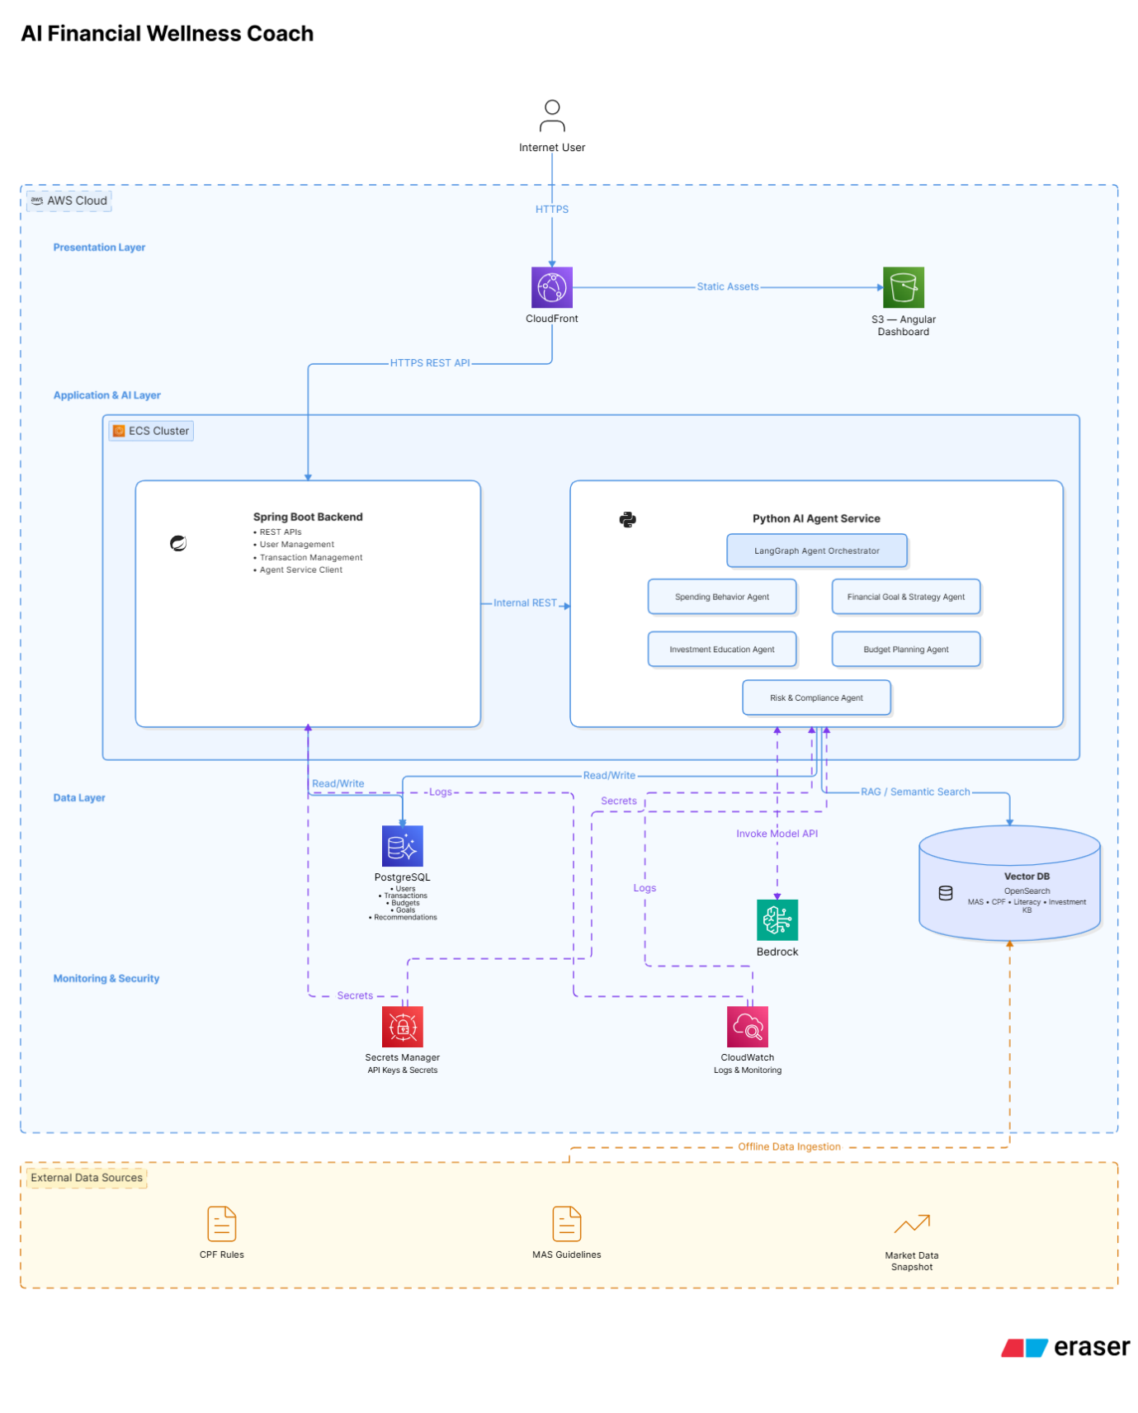
Architecture Explanation:
- Presentation Tier: Angular hosted on Amazon S3 and served via CloudFront.
- Application Tier: Spring Boot backend running as an ECS container.
- AI Tier: Separate Python AI Agent Service running in another ECS container, containing the LangGraph Agent Orchestrator, agents, and Bedrock.
- Data Tier: Amazon PostgreSQL for transactional data and a Vector Database for Retrieval-Augmented Generation (RAG).
- Supporting Services: AWS Secrets Manager for secure credential management and Amazon CloudWatch for logging and monitoring.
- External Data Sources: MAS guidelines, CPF rules, and financial literacy resources are ingested offline into the vector database, ensuring the AI service performs RAG against a controlled knowledge base rather than relying on live external API calls.

Project Scope
Describe the agents in your system. Explain how your implementation will demonstrate key considerations, e.g., assurance, trust, fairness, accountability, ethical issues, explainability, governance, security measures, agent autonomous and orchestration, as well as MLOps and LLMOps practices.
The solution consists of 5 independent LLM agents with an Agent Orchestrator act as the central decision-maker.
Agent Responsibilities & Key Considerations
AI Agent | Responsibilities | Key Design Considerations Demonstrated
Spending Agent | Analyses user spending behaviour and detects spending patterns, detect unusual expenditure, and generate monthly spending summaries. Provides insights into spending habits instead of merely listing transactions. | Autonomy: Independently analyses newly uploaded transactions.  Explainability: Explains why a spending pattern or anomaly is detected (e.g., "Dining expenses increased by 35% compared to last month").  Trust & Fairness: Uses actual transaction data without making assumptions about lifestyle.  Accountability: Stores analysis results with timestamps and audit logs.
Budget Agent | Generates personalized monthly budgets based on historical spending, income, recurring expenses and financial goals. Continuously adjusts budget recommendations when spending behaviour changes. | Assurance: Budget recommendations are generated from actual spending history and configurable budgeting rules.  Explainability: Provides rationale behind each recommended budget allocation.  Ethics & Fairness: Avoids unrealistic or discriminatory recommendations by considering user-defined preferences instead of demographic assumptions.  Governance: Recommendations follow configurable business rules and spending thresholds.
Goal Strategy Agent | Plans long-term financial strategies based on user goals (e.g., emergency fund, vacation, home purchase). Evaluates savings progress and suggests adjustments when users fall behind schedule. | Agent Autonomy: Independently monitors financial progress and proactively recommends strategy adjustments.  Explainability: Shows calculations behind projected completion dates and required monthly savings.  Trust: Uses transparent assumptions and allows users to modify goals.  Governance: All recommendations remain advisory; users retain final decision-making authority.
Investment Education Agent | Provides educational content on investment concepts (e.g., diversification, ETFs, risk tolerance, compound interest). Recommends learning materials based on user knowledge level without providing financial advice. | Ethical AI: Clearly distinguishes educational information from regulated financial advice.  Trust: Includes disclaimers that recommendations are for learning purposes only.  Explainability: Explains concepts using plain language and examples.  Fairness: Delivers consistent educational content regardless of user profile.  Security: Does not access unnecessary personal financial information.
Risk & Compliance Agent | Reviews outputs generated by other agents, validates recommendations against predefined financial policies, detects conflicting advice, identifies high-risk situations, and applies safety guardrails before responses are returned to users. | Governance: Acts as the final validation layer before recommendations are presented.  Trust & Assurance: Prevents unsafe or contradictory financial recommendations.  Accountability: Logs validation decisions and reasons for rejecting or modifying recommendations.  Security: Prevents prompt injection and validates agent outputs before release.  Explainability: Explains why recommendations are blocked or revised.

Scope Considerations (Applied to All Agents)
Area | How It Is Addressed in the System
Assurance | - Recommendations are validated by the Risk & Compliance Agent before presentation.  - Rule-based guardrails prevent unsafe or inconsistent outputs.  - Confidence scores and validation status are recorded for auditing.
Trust | - Every recommendation includes a clear explanation of how it was derived.  - Educational content is explicitly separated from financial advice.  - Users remain in control of financial decisions.
Fairness | - Recommendations are generated based on individual financial data and user-defined goals rather than demographic characteristics.  - The system applies consistent evaluation criteria across all users.
Accountability | - Each agent records its execution details, timestamps, inputs, and outputs.  - AWS CloudWatch logs execution history provides a complete audit trail.
Explainability | - Agents provide supporting reasons for each recommendation.  - Users can understand how spending patterns, budgets, and savings strategies were derived.
Governance | - The Risk & Compliance Agent enforces business rules before any recommendation is returned.  - Consent and user permissions are validated before accessing financial information.
Security | - APIs are protected using JWT tokens.  - Financial data is encrypted at rest and in transit.  - Least-privilege IAM roles restrict access between AWS services.
Agent Autonomy | - Specialized agents independently perform their designated tasks.  - The Agent Orchestrator dynamically selects which agents to invoke based on user intent.
LLMOps | - Prompts are version-controlled, responses are monitored, and guardrails are applied through the Risk & Compliance Agent. Prompt templates can be updated without changing application code.

Project Plan

Project Work Breakdown Structure (WBS)
List the rough WBS tasks and their estimated efforts. This is to ensure that you have thought about the approach and the implementation effort.
S/N | Task | Description | Person Assigned  (One name per row) | Estimated effort (Person-days)
1 | Project Planning & Ethics | Scope, risks, responsible AI framing | Sky Lee Jet Xuen | 0.5
1 | Project Planning & Ethics | Scope, risks, responsible AI framing | Lim Keng Yen Bernard | 0.5
1 | Project Planning & Ethics | Scope, risks, responsible AI framing | Mar Wen Hee | 0.5
1 | Project Planning & Ethics | Scope, risks, responsible AI framing | Lai Xin Kai | 0.5
1 | Project Planning & Ethics | Scope, risks, responsible AI framing | Tan Sean Leng | 0.5
2 | Architecture Design | Logical architecture, agent interactions,  Database design | Sky Lee Jet Xuen | 1
2 | Architecture Design | Logical architecture, agent interactions,  Database design | Lim Keng Yen Bernard | 1
2 | Architecture Design | Logical architecture, agent interactions,  Database design | Mar Wen Hee | 1
2 | Architecture Design | Logical architecture, agent interactions,  Database design | Lai Xin Kai | 1
2 | Architecture Design | Logical architecture, agent interactions,  Database design | Tan Sean Leng | 1
3 | Database Setup | Database configuration, connection, schema & table creation | Mar Wen Hee | 0.5
3 | Database Setup | Database configuration, connection, schema & table creation | Lai Xin Kai | 0.5
4 | LLMOps Setup | S3, GitHub Repository, GitHub Actions, SonarQube for static code analysis, Tests integration, Docker build, ECS deployment, runtime monitoring and CloudWatch | Tan Sean Leng | 2
4 | LLMOps Setup |  | Lim Keng Yen Bernard | 2
5 | Spending Agent | Uses LLM reasoning with structured prompts and financial categorisation rules. | Lai Xin Kai | 4
6 | Spending Dashboard UI | Dashboard display user spending pattern | Lai Xin Kai | 3
7 | Testing – Spending Agent | - Prompt testing  - Unit tests  - Prompt injection testing  - Guardrail validation | Lai Xin Kai | 3
8 | Budget Agent | LLM reasoning constrained by predefined budgeting rules. | Tan Sean Leng | 4
9 | Budget Dashboard UI | Dashboard display user budget | Tan Sean Leng | 3
 | Testing Budget Agent | - Prompt testing  - Unit tests  - Prompt injection testing  - Guardrail validation | Tan Sean Leng | 3
10 | Goal Strategy Agent | Goal decomposition using LLM reasoning. | Lim Keng Yen Bernard | 4
11 | Overall Angular Chatbot UI | Main screen with Chatbot | Lim Keng Yen Bernard | 3
12 | Testing – Goal Strategy Agent | - Prompt testing  - Unit tests  - Prompt injection testing  - Guardrail validation | Lim Keng Yen Bernard | 3
13 | Investment Education Agent | RAG + LLM  Uses trusted financial resources. | Mar Wen Hee | 5
14 | RAG Setup | - Prepare trusted documents and store in S3  - Create embeddings | Mar Wen Hee | 2
15 | Testing Investment Education Agent | - Prompt testing  - Unit tests  - Prompt injection testing  - Guardrail validation | Mar Wen Hee | 3
16 | Risk & Compliance Agent | Hybrid:  - Rule Engine  - LLM verification | Sky Lee Jet Xuen | 4
17 | Testing Risk & Compliance Agent | - Prompt testing  - Unit tests  - Prompt injection testing  - Guardrail validation | Sky Lee Jet Xuen | 3
18 | Agent Orchestrator | (LLM) analyses the user's intent before dynamically deciding which specialist agents should participate. Unlike rule-based routing, the selected agents vary according to the user's request. | Sky Lee Jet Xuen | 3.5
19 | Documentation & Presentation | Final report & slides | Sky Lee Jet Xuen | 1
19 | Documentation & Presentation | Final report & slides | Tan Sean Leng | 1
19 | Documentation & Presentation | Final report & slides | Lim Keng Yen Bernard | 1
19 | Documentation & Presentation | Final report & slides | Lai Xin Kai | 1
19 | Documentation & Presentation | Final report & slides | Mar Wen Hee | 1

Effort Summary
Team Member | Total Estimated effort (Person-days)
Lee Jet Xuen (Sky) | 13
Lim Keng Yen Bernard | 14.5
Mar Wen Hee | 13
Lai Xin Kai | 13
Tan Sean Leng | 14.5

